

**SWAMI RAMANAND TEERTH MARATHWADA UNIVERSITY, NANDED**

## PROJECT REPORT ON

Lite Speed Racing

Submitted by

## Mr.Omkar Kundlik Dharme

## Mr.Rohit Sunjay Patil

## Mr.Shripad Satish Shahane

**GUIDE BY**

**Ms. G.A Deshmukh**

## DEPARTMENT OF COMPUTER SCIENCE DNYANOPASAK COLLEGE OF ARTS, SCIENCE AND COMMERCE

**PARBHANI, MAHARASHTRA. (2021-2022)**

**CERTIFICATE**



This is to certify that the project entitled

**“Lite Speed Racing”**

Submitted by

Mr.Omkar Kundlik Dharme

Mr.Rohit Sanjay Patil

Mr.Shripad Satish Shahane

## To The

### Swami Ramanand Teerth Marathwada University, Nanded

Developed At

**Dnyanopasak college of arts, science and commerce**

## Parbhani.

In Partial Fulfilment of requirements for the degree of Bachelor of computer science

In the subject of PROJECT WORK Under my guidance and Supervisions to the best of my knowledge

Ms.G.A Deshmukh Mrs.P.B Khanale

Guide External H.O.D.

## DECLARATION

### To,

**The principal**, **Dnyanopasak college, Parbhani.**

I hereby declare that My BCS Third year project is

“Lite Speed Racing**”** Which has been developed in Department Of Computer Science Dnyanopasak College Of Arts, Science And Commerce Parbhani, Maharashtra**,** in such language C#.

I also declare that My project is Original and has been not Copied from any other source. For this I would like to thanks my principal, my head of department and my lecturer for giving us an excellent opportunity and freedom on project.

Thanking You,

Yours Sincerely,

## ACKNOLEDGEMENT

I like to share our sincere gratitude to all those who help us in completion of this project. During the work faced many challenges due to my lack of knowledge and experience but these people help us to get over from all the difficulties and in final compilation of our idea to a shaped sculpture.

I wish to express our deep sense of gratitude to our guide**, Ms. G.A Deshmukh mam** (lecturer of computer department, Dnyanopasak college of arts, Parbhani) **Mr.P.B.Khanale sir (**H.O.D of computer department, Dnyanopasak college Parbhani**)** for his valuable guidance, keen interest, constructive suggestions and sustained encouragement throughout the project work.

I am also thankful to my whole class and most of all to my parents who have inspired me to face all challenges and win all hurdles in life.

Date : June 11,2022 Omkar Dharme

Rohit Patil

Shripad Shahane

Place: DSM College, Parbhani. BSc. (CS) TY

INDEX

|  |  |  |
| --- | --- | --- |
| SR. NO. | TITLE | PAGE NO |
| 1. | Introduction | 6 |
| 2. | Object | 7 |
| 3. | Goal | 7 |
| 4. | Need of System | 7 |
| 5. | Game Development Progress report 1 | 9 |
| 6. | Game Development Progress report 2 | 10 |
| 7. | Game Development Progress report 3 | 11 |
| 8. | System Flow Diagram/DFD | 12 |
| 9. | Screenshots | 13 |
| 10. | Result | 56 |
| 11. | Conclusion | 57 |
| 12. | Reference | 58 |
|  |  |  |

**INTRODUCTION**

For this Car Racing Game, we would like to accomplish a video game imitating the existing game showed as Figure 1 with a projective view. The theme of our game is to compete with time in a racing tournament the player’s goal is to get to the destination as soon as possible while trying to avoid bumping to road object. The final score will be posted according to the best lap time

Generally, The games are made with large Developers Teams. But due to lack of time and resources this project is made in Unity game ingine with team of three members. Most of the racing game are played with Multiplayer or AI Oponants but this game is single player (solo) . The Aim is to archive the best lap time in lowest timeperio

**Objective :**

Objective of the Lite speed racing game project is to build Race game which is user friendly enough ane gamer fullfill their need.

**Goal :**

1. To make a user friendly game.

1. To provide 24*7 gaming facility to the gamer.
2. To provide a accurate and instanat game score and last

high score.

1. To make good documentation so as to facilitate possible feature enhancements.

**Need of System :**

There is always a need of system that will help the game lovers to play at any time and anywhere.

Project Approval Letter…….

Lite Speed Racing

Game Development Progress report 1

Developer’s Full Name 1) Omkar Kundlik Dharme

2) Rohit Sanjay Patil

3) Shripad Satish shahane

Date/Time started Monday ,March 28, 2022 12:30pm

Target Date Saturday, June 11, 2022

Progress of Work(%) 35/100

**How much of the Work is Completed ?**

We have learned about basics of game engine. Then we learned about how to create Basic vehicle and Car mechanics. We Collect each and every software and Game engine are required for our project. We have created all the required 3d models of our Game using Blender 3d Software.

**Remaining Work Items:**

We need to import our 3d models from Blender to UNITY Game engine. We need to setup Unity Game engine as par our project requirement.

We need to create Game mechanics and some logic using C# programming language.

**Experienced Challenges:**

In our project at the time of making asset in blender are not rendered easily and that’s why our systems may crashes several times.

**How were the Challenges Handled?**

We found lots of documentation from internet . The documents really helped a lot to solve the problems, and fix the bugs and gliches. Also we watched some Youtube videos to resolve some issues.

Lite Speed Racing

Game Development Progress report 2

Developer’s Full Name 1) Omkar Kundlik Dharme

2) Rohit Sanjay Patil

3) Shripad Satish shahane

Date/Time started Monday ,April 28, 2022 12:30pm

Target Date Saturday, June 11, 2022

Progress of Work(%) 70/100

**How much of the Work is Completed?**

We have created all of our 3D assets and all the required vehicle mechanics using C# script. And now we have implemented it to using **UNITY** Game Engine. Now the car is moving as per our requirement.

**Remainig Work Items:**

As we have created the vehicle and basic test map for our game, it requires good looking map and a race track. It need some graphics improvements. We need to optimize the Gameplay and performance of the game.

**Experienced Challenges:**

When we created the C# scripts it creates some error or Bugs they needs to be fixed before Building the Game. When we make the good graphics game it causes some serious performance issues that also needs to be fixed.

**How were the Challenges Handled?**

When we need to fix the errors or Bugs, we need to find the reference of what we’re creating or for what purpose the script is being created. So I went to the Unity support forum and found my all solutions.

Lite Speed Racing

Game Development Progress report 3

Developer’s Full Name 1) Omkar Kundlik Dharme

2) Rohit Sanjay Patil

3) Shripad Satish shahane

Date/Time started Monday ,May 28, 2022 12:30pm

Target Date Saturday, June 11, 2022

Progress of Work(%) 100/100

**How much of the Work is Completed?**

At this time our project is nearly done. We have reached the minimum requirement of the project work. And we can improve the UI as it engages the Player to interact with the Game. We have improved the Gameplay performance.

**Remainig Work Items:**

As the project reached to end it need to be visually appealing to play. So we need to implement the UI for player to interact.

**Experienced Challenges:**

The performance issue was real problem, when we use high quality assets they cost very high amount of memory and CPU power as they need to be render high quality textures.

**How were the Challenges Handled?**

At this stage of Game Development we have experienced many problems. So, above challenges were really easy to handles as it requires basic knowledge of image editing software and some basic scripting.

**System Flow Diagram/DFD** 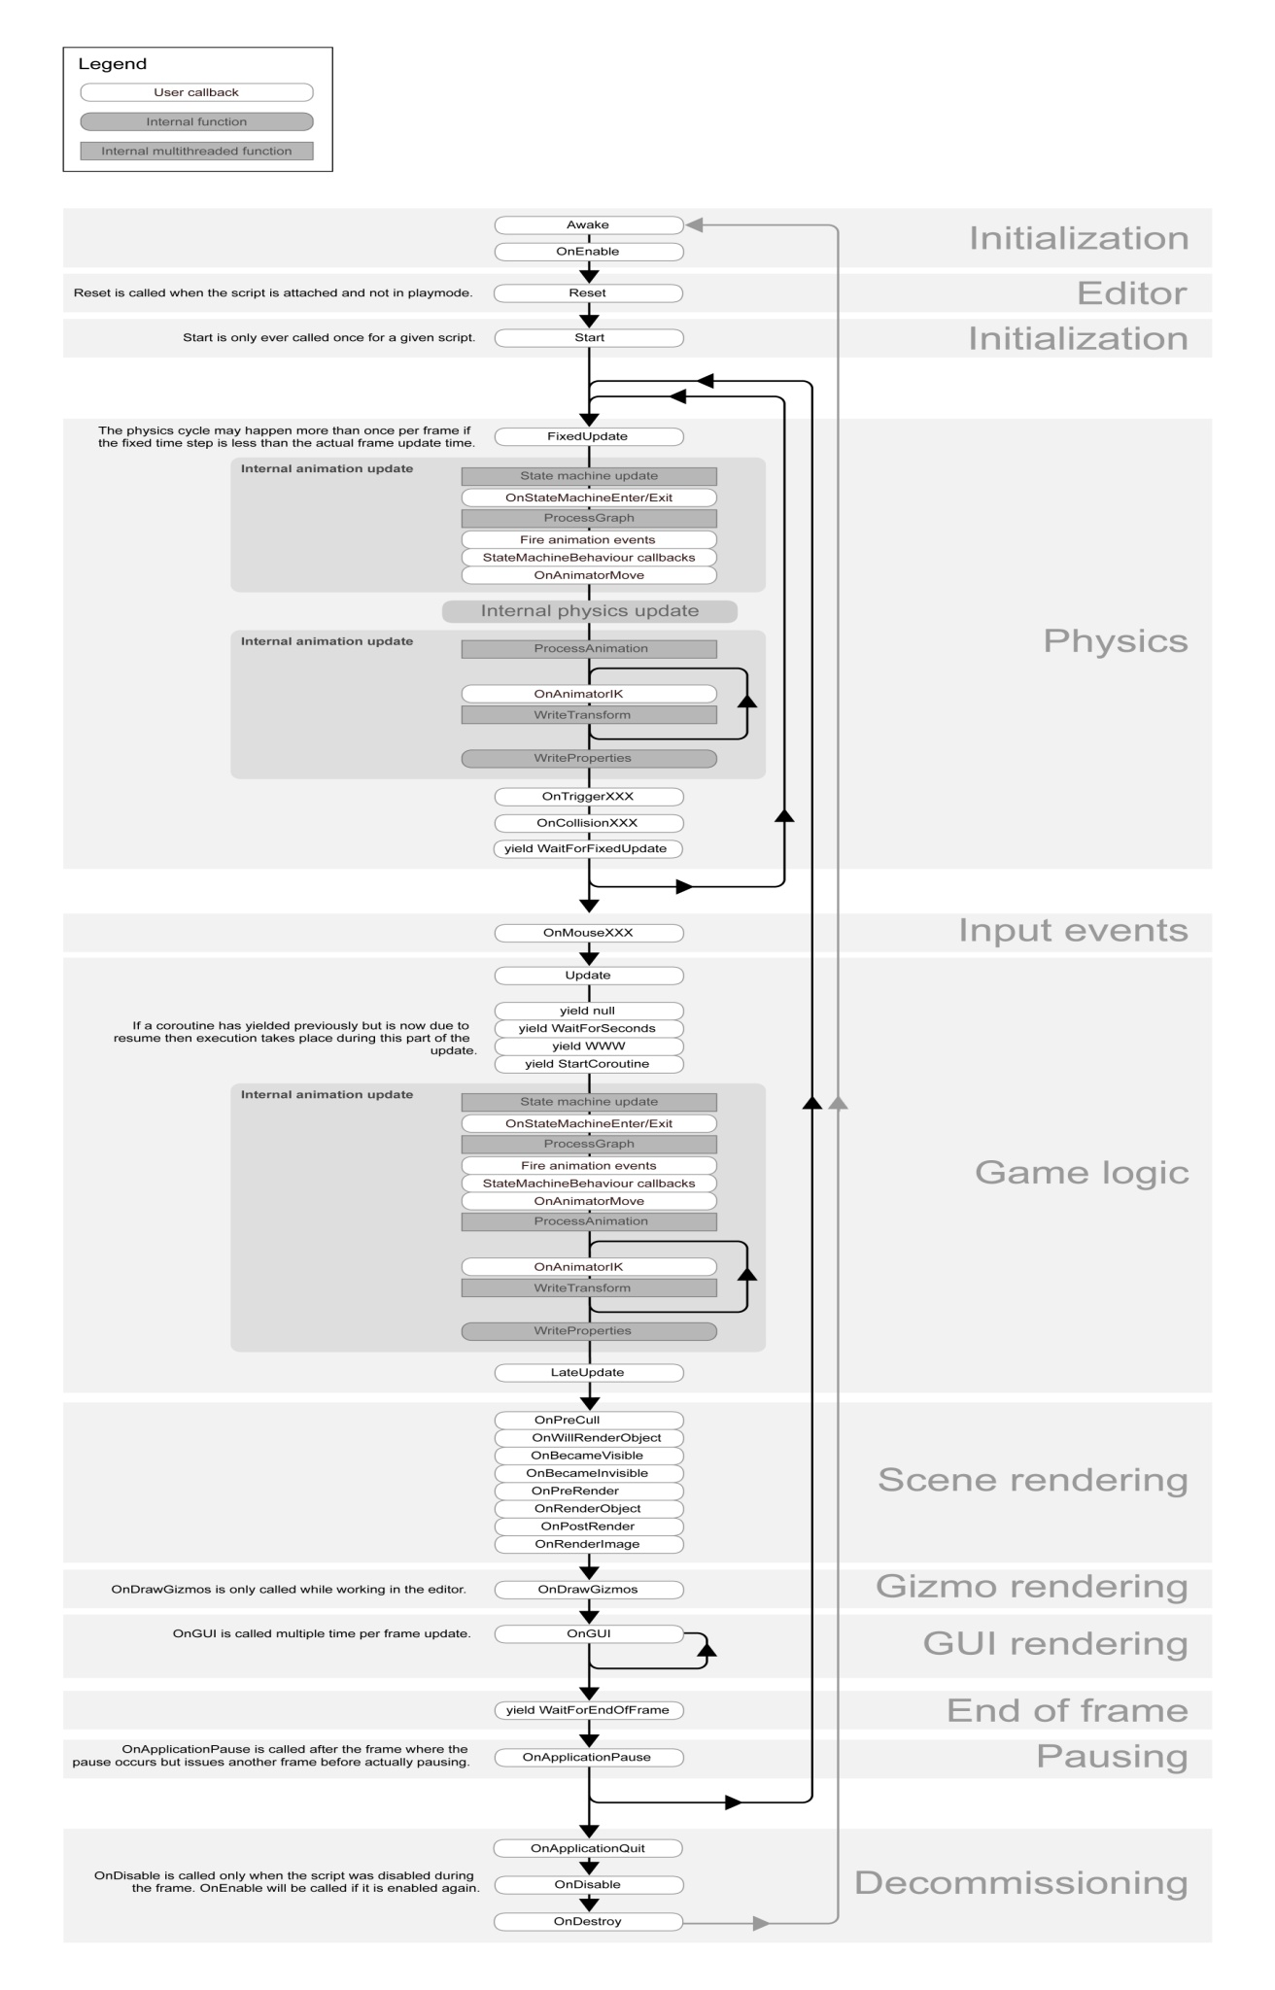:- this flowchart show the universal dataflow in unity Game engine.

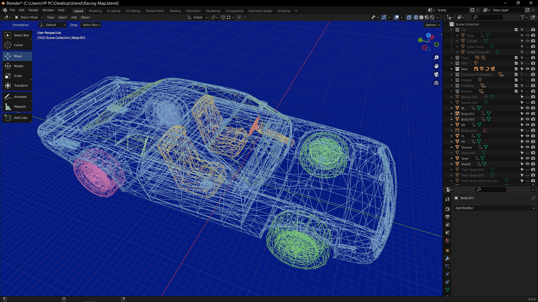

Screenshot:- Vehicle

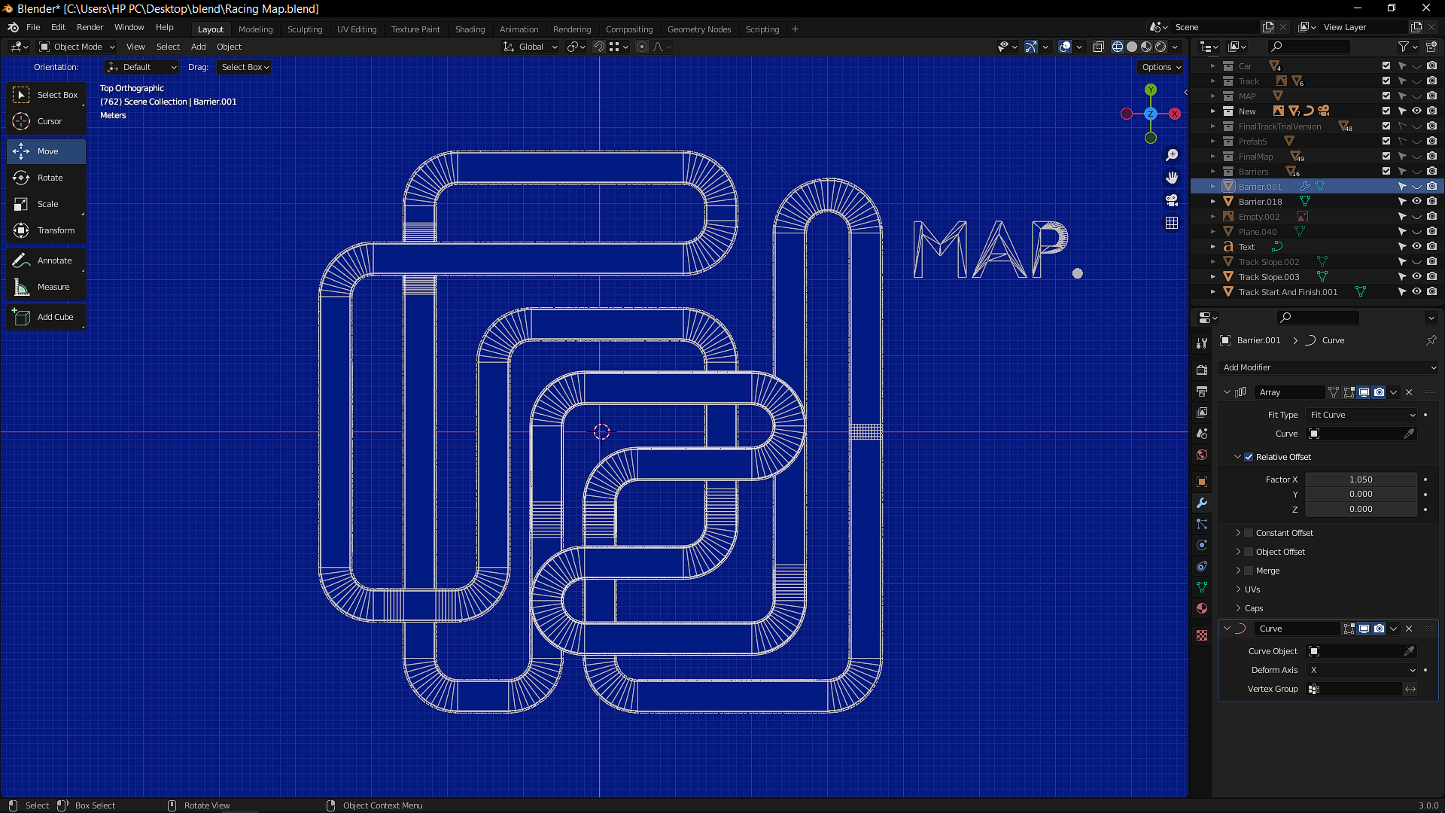Screenshot:- RACE TRACK

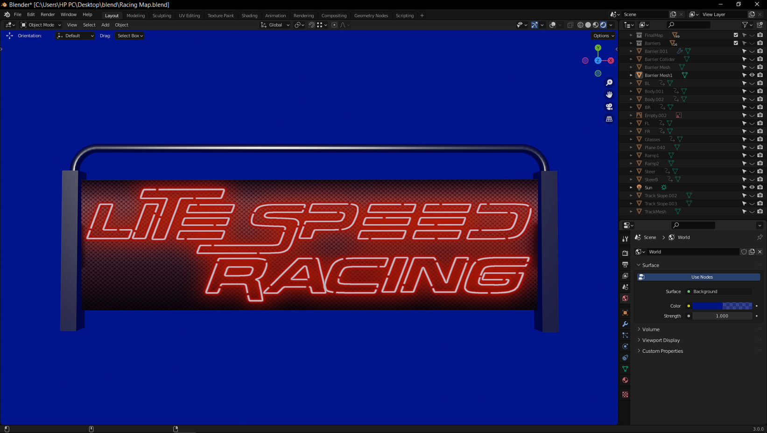

Screenshot:- BARRIER

Screenshot:-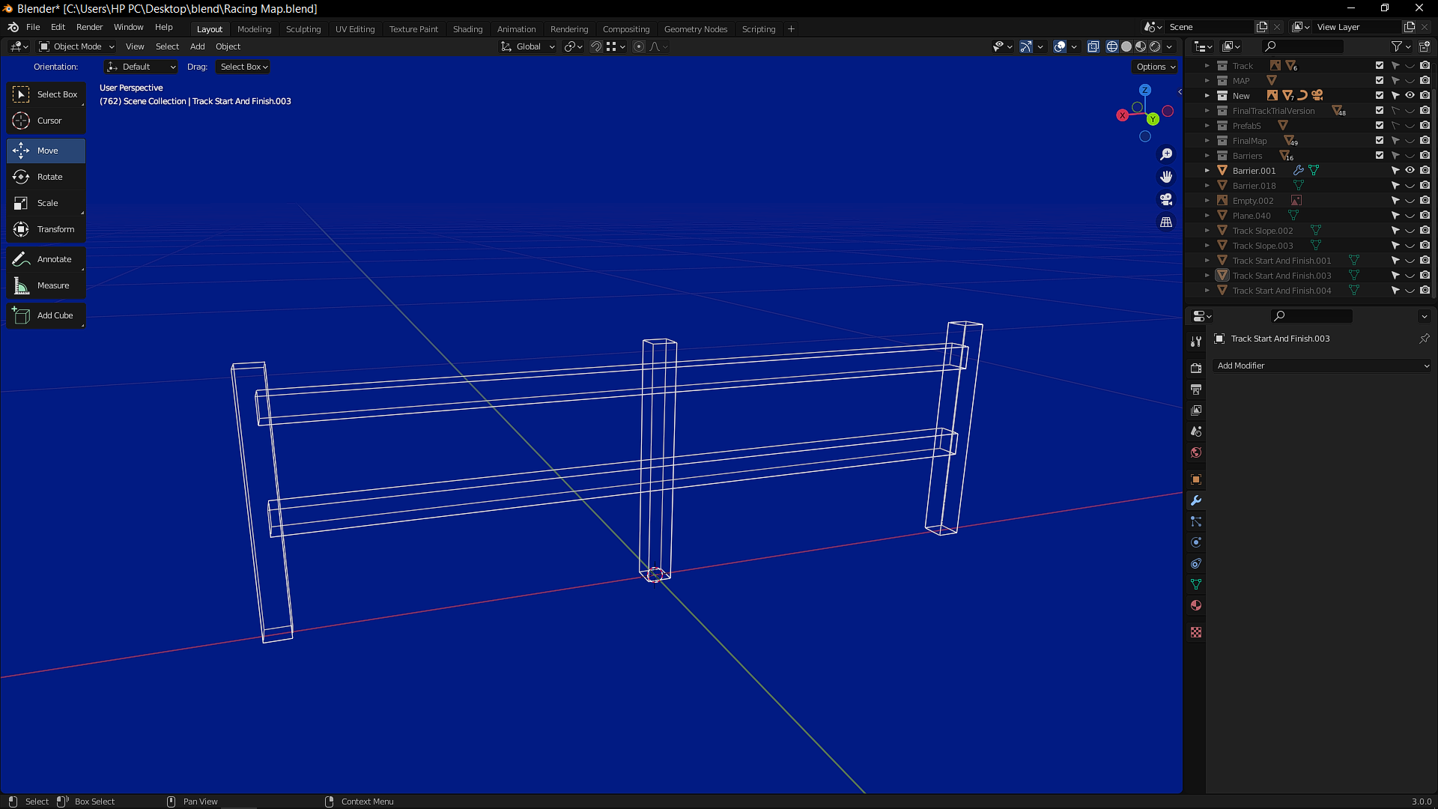 FLYOVER BARRIER

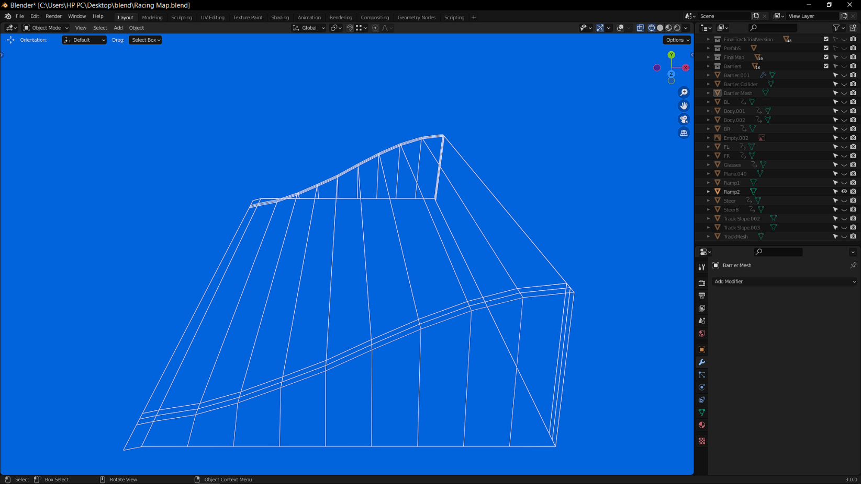Screenshot:- RAMP

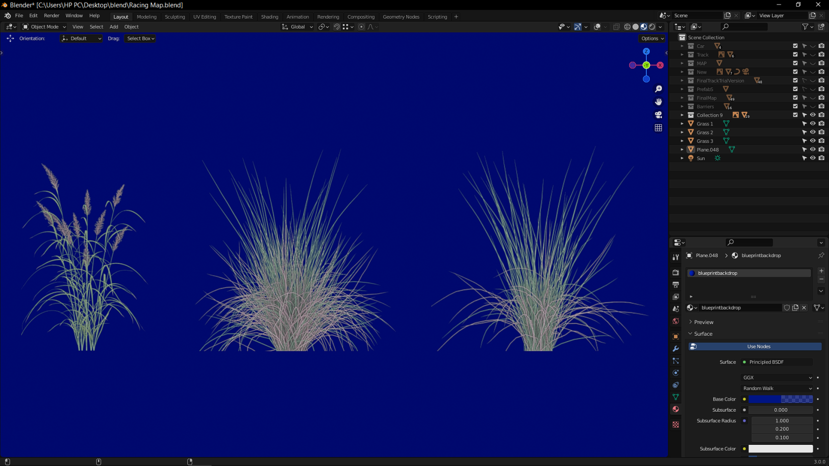Screenshot:-GRASS

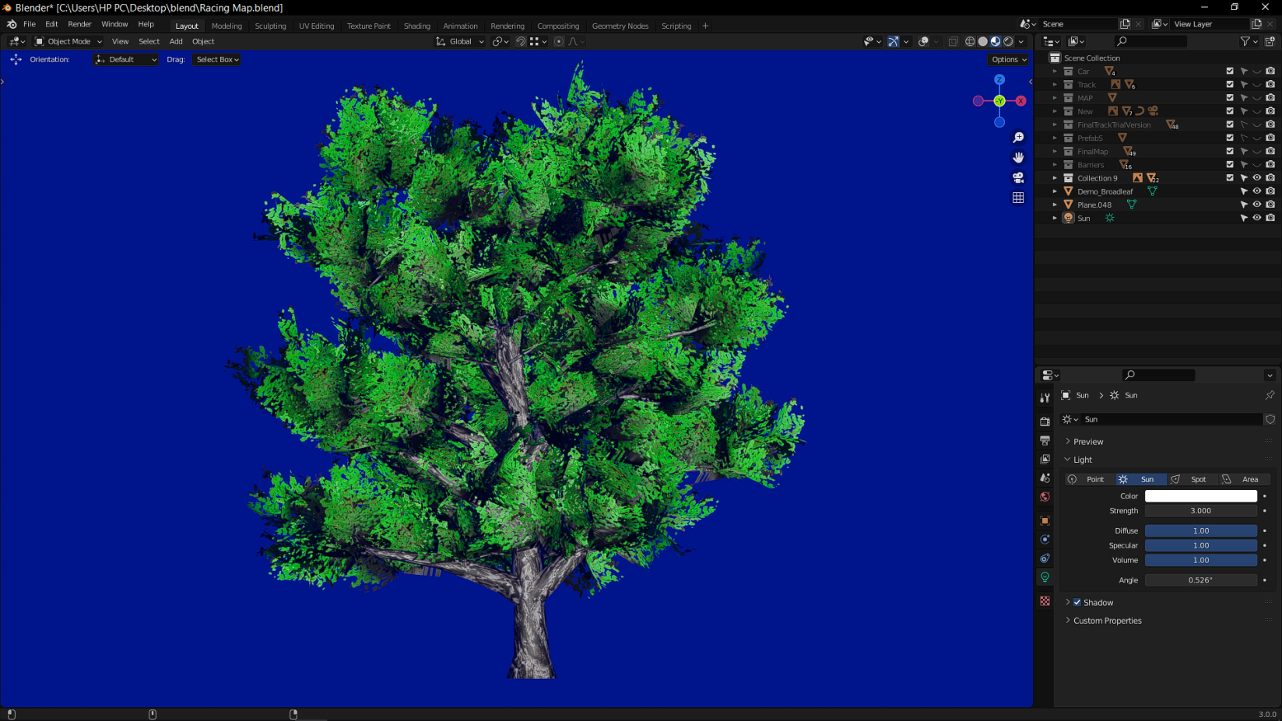Screenshot:-TREE

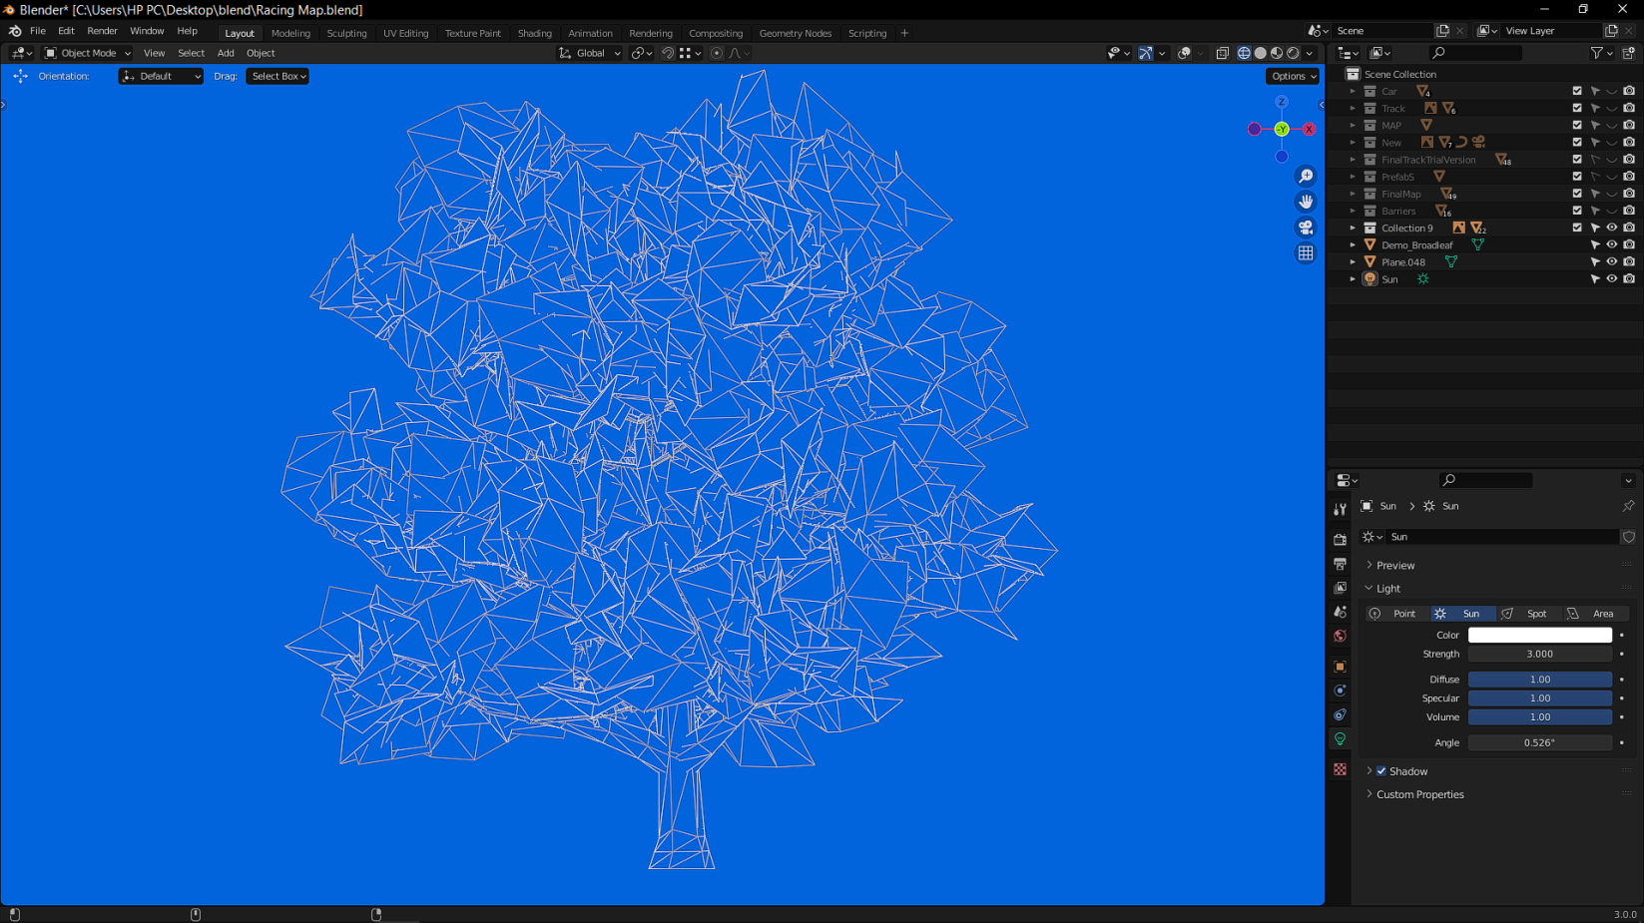Screenshot:-TREE MESH

**SOURCE CODE**

**FULL VEHICLE CONTROL**

using UnityEngine;

using System.Collections;

using System.Collections.Generic;

using UnityEngine.UI;

public enum ControlMode { simple = 1, touch = 2 }

public class VehicleControl : MonoBehaviour

{

public ControlMode controlMode = ControlMode.simple;

public bool activeControl = false;

// Wheels Setting /////////////////////////////////

public CarWheels carWheels;

[System.Serializable]

public class CarWheels

{

public ConnectWheel wheels;

public WheelSetting setting;

}

[System.Serializable]

public class ConnectWheel

{

public bool frontWheelDrive = true;

public Transform frontRight;

public Transform frontLeft;

public bool backWheelDrive = true;

public Transform backRight;

public Transform backLeft;

}

[System.Serializable]

public class WheelSetting

{

public float Radius = 0.4f;

public float Weight = 1000.0f;

public float Distance = 0.2f;

}

// Lights Setting ////////////////////////////////

public CarLights carLights;

[System.Serializable]

public class CarLights

{

public Light[] brakeLights;

public Light[] reverseLights;

}

// Car sounds /////////////////////////////////

public CarSounds carSounds;

[System.Serializable]

public class CarSounds

{

public AudioSource IdleEngine, LowEngine, HighEngine;

public AudioSource nitro;

public AudioSource switchGear;

}

// Car Particle /////////////////////////////////

public CarParticles carParticles;

[System.Serializable]

public class CarParticles

{

public GameObject brakeParticlePerfab;

public ParticleSystem shiftParticle1, shiftParticle2;

private GameObject[] wheelParticle = new GameObject[4];

}

// Car Engine Setting /////////////////////////////////

public CarSetting carSetting;

[System.Serializable]

public class CarSetting

{

public bool showNormalGizmos = false;

public Transform carSteer;

public HitGround[] hitGround;

public List<Transform> cameraSwitchView;

public float springs = 25000.0f;

public float dampers = 1500.0f;

public float carPower = 120f;

public float shiftPower = 150f;

public float brakePower = 8000f;

public Vector3 shiftCentre = new Vector3(0.0f, -0.8f, 0.0f);

public float maxSteerAngle = 25.0f;

public float shiftDownRPM = 1500.0f;

public float shiftUpRPM = 2500.0f;

public float idleRPM = 500.0f;

public float stiffness = 2.0f;

public bool automaticGear = true;

public float[] gears = { -10f, 9f, 6f, 4.5f, 3f, 2.5f };

public float LimitBackwardSpeed = 60.0f;

public float LimitForwardSpeed = 220.0f;

}

[System.Serializable]

public class HitGround

{

public string tag = "street";

public bool grounded = false;

public AudioClip brakeSound;

public AudioClip groundSound;

public Color brakeColor;

}

//////////////////////////////////////////////////////////////////////////////////////////////////////////////

private float steer = 0;

private float accel = 0.0f;

[HideInInspector]

public bool brake;

private bool shifmotor;

[HideInInspector]

public float curTorque = 100f;

[HideInInspector]

public float powerShift = 100;

[HideInInspector]

public bool shift;

private float torque = 100f;

[HideInInspector]

public float speed = 0.0f;

private float lastSpeed = -10.0f;

private bool shifting = false;

float[] efficiencyTable = { 0.6f, 0.65f, 0.7f, 0.75f, 0.8f, 0.85f, 0.9f, 1.0f, 1.0f, 0.95f, 0.80f, 0.70f, 0.60f, 0.5f, 0.45f, 0.40f, 0.36f, 0.33f, 0.30f, 0.20f, 0.10f, 0.05f };

float efficiencyTableStep = 250.0f;

private float Pitch;

private float PitchDelay;

private float shiftTime = 0.0f;

private float shiftDelay = 0.0f;

[HideInInspector]

public int currentGear = 0;

[HideInInspector]

public bool NeutralGear = true;

[HideInInspector]

public float motorRPM = 0.0f;

[HideInInspector]

public bool Backward = false;

//////////////////////////////////////////////TouchMode(Control)////////////////////////////////////////////

[HideInInspector]

public float accelFwd = 0.0f;

[HideInInspector]

public float accelBack = 0.0f;

[HideInInspector]

public float steerAmount = 0.0f;

////////////////////////////////////////////////////////////////////////////////////////////////////////////////////////

private float wantedRPM = 0.0f;

private float w_rotate;

private float slip, slip2 = 0.0f;

private GameObject[] Particle = new GameObject[4];

private Vector3 steerCurAngle;

private Rigidbody myRigidbody;

/////////////////////////////////////////////////////////////////////////////////

private WheelComponent[] wheels;

private class WheelComponent

{

public Transform wheel;

public WheelCollider collider;

public Vector3 startPos;

public float rotation = 0.0f;

public float rotation2 = 0.0f;

public float maxSteer;

public bool drive;

public float pos_y = 0.0f;

}

private WheelComponent SetWheelComponent(Transform wheel, float maxSteer, bool drive, float pos_y)

{

WheelComponent result = new WheelComponent();

GameObject wheelCol = new GameObject(wheel.name + "WheelCollider");

wheelCol.transform.parent = transform;

wheelCol.transform.position = wheel.position;

wheelCol.transform.eulerAngles = transform.eulerAngles;

pos_y = wheelCol.transform.localPosition.y;

WheelCollider col = (WheelCollider)wheelCol.AddComponent(typeof(WheelCollider));

result.wheel = wheel;

result.collider = wheelCol.GetComponent<WheelCollider>();

result.drive = drive;

result.pos_y = pos_y;

result.maxSteer = maxSteer;

result.startPos = wheelCol.transform.localPosition;

return result;

}

void Awake()

{

if (carSetting.automaticGear) NeutralGear = false;

myRigidbody = transform.GetComponent<Rigidbody>();

wheels = new WheelComponent[4];

wheels[0] = SetWheelComponent(carWheels.wheels.frontRight, carSetting.maxSteerAngle, carWheels.wheels.frontWheelDrive, carWheels.wheels.frontRight.position.y);

wheels[1] = SetWheelComponent(carWheels.wheels.frontLeft, carSetting.maxSteerAngle, carWheels.wheels.frontWheelDrive, carWheels.wheels.frontLeft.position.y);

wheels[2] = SetWheelComponent(carWheels.wheels.backRight, 0, carWheels.wheels.backWheelDrive, carWheels.wheels.backRight.position.y);

wheels[3] = SetWheelComponent(carWheels.wheels.backLeft, 0, carWheels.wheels.backWheelDrive, carWheels.wheels.backLeft.position.y);

if (carSetting.carSteer)

steerCurAngle = carSetting.carSteer.localEulerAngles;

foreach (WheelComponent w in wheels)

{

WheelCollider col = w.collider;

col.suspensionDistance = carWheels.setting.Distance;

JointSpring js = col.suspensionSpring;

js.spring = carSetting.springs;

js.damper = carSetting.dampers;

col.suspensionSpring = js;

col.radius = carWheels.setting.Radius;

col.mass = carWheels.setting.Weight;

WheelFrictionCurve fc = col.forwardFriction;

fc.asymptoteValue = 5000.0f;

fc.extremumSlip = 2.0f;

fc.asymptoteSlip = 20.0f;

fc.stiffness = carSetting.stiffness;

col.forwardFriction = fc;

fc = col.sidewaysFriction;

fc.asymptoteValue = 7500.0f;

fc.asymptoteSlip = 2.0f;

fc.stiffness = carSetting.stiffness;

col.sidewaysFriction = fc;

}

}

public void ShiftUp()

{

float now = Time.timeSinceLevelLoad;

if (now < shiftDelay) return;

if (currentGear < carSetting.gears.Length - 1)

{

// if (!carSounds.switchGear.isPlaying)

carSounds.switchGear.GetComponent<AudioSource>().Play();

if (!carSetting.automaticGear)

{

if (currentGear == 0)

{

if (NeutralGear){currentGear++;NeutralGear = false;}

else

{ NeutralGear = true;}

}

else

{

currentGear++;

}

}

else

{

currentGear++;

}

shiftDelay = now + 1.0f;

shiftTime = 1.5f;

}

}

public void ShiftDown()

{

float now = Time.timeSinceLevelLoad;

if (now < shiftDelay) return;

if (currentGear > 0 || NeutralGear)

{

//w if (!carSounds.switchGear.isPlaying)

carSounds.switchGear.GetComponent<AudioSource>().Play();

if (!carSetting.automaticGear)

{

if (currentGear == 1)

{

if (!NeutralGear){currentGear--;NeutralGear = true;}

}

else if (currentGear == 0){NeutralGear = false;}else{currentGear--;}

}

else

{

currentGear--;

}

shiftDelay = now + 0.1f;

shiftTime = 2.0f;

}

}

void OnCollisionEnter(Collision collision)

{

if (collision.transform.root.GetComponent<VehicleControl>())

{

collision.transform.root.GetComponent<VehicleControl>().slip2 = Mathf.Clamp(collision.relativeVelocity.magnitude, 0.0f, 10.0f);

myRigidbody.angularVelocity = new Vector3(-myRigidbody.angularVelocity.x * 0.5f, myRigidbody.angularVelocity.y * 0.5f, -myRigidbody.angularVelocity.z * 0.5f);

myRigidbody.velocity = new Vector3(myRigidbody.velocity.x, myRigidbody.velocity.y * 0.5f, myRigidbody.velocity.z);

}

}

void OnCollisionStay(Collision collision)

{

if (collision.transform.root.GetComponent<VehicleControl>())

collision.transform.root.GetComponent<VehicleControl>().slip2 = 5.0f;

}

///////////////////////////////////////////////////////////////////////////////////////////////////////////////////////

void Update()

{

if (!carSetting.automaticGear && activeControl)

{

if (Input.GetKeyDown("page up"))

{

ShiftUp();

}

if (Input.GetKeyDown("page down"))

{

ShiftDown();

}

}

}

void FixedUpdate()

{

// speed of car

speed = myRigidbody.velocity.magnitude * 2.7f;

if (speed < lastSpeed - 10 && slip < 10)

{

slip = lastSpeed / 15;

}

lastSpeed = speed;

if (slip2 != 0.0f)

slip2 = Mathf.MoveTowards(slip2, 0.0f, 0.1f);

myRigidbody.centerOfMass = carSetting.shiftCentre;

if (activeControl)

{

if (controlMode == ControlMode.simple)

{

accel = 0;

brake = false;

shift = false;

if (carWheels.wheels.frontWheelDrive || carWheels.wheels.backWheelDrive)

{

steer = Mathf.MoveTowards(steer, Input.GetAxis("Horizontal"), 0.2f);

accel = Input.GetAxis("Vertical");

brake = Input.GetButton("Jump");

shift = Input.GetKey(KeyCode.LeftShift) | Input.GetKey(KeyCode.RightShift);

}

}

else if (controlMode == ControlMode.touch)

{

if (accelFwd != 0) { accel = accelFwd; } else { accel = accelBack; }

steer = Mathf.MoveTowards(steer, steerAmount, 0.07f);

}

}

else

{

accel = 0.0f;

steer = 0.0f;

brake = false;

shift = false;

}

if (!carWheels.wheels.frontWheelDrive && !carWheels.wheels.backWheelDrive)

accel = 0.0f;

if (carSetting.carSteer)

carSetting.carSteer.localEulerAngles = new Vector3(steerCurAngle.x, steerCurAngle.y, steerCurAngle.z + (steer * -120.0f));

if (carSetting.automaticGear && (currentGear == 1) && (accel < 0.0f))

{

if (speed < 5.0f)

ShiftDown();

}

else if (carSetting.automaticGear && (currentGear == 0) && (accel > 0.0f))

{

if (speed < 5.0f)

ShiftUp();

}

else if (carSetting.automaticGear && (motorRPM > carSetting.shiftUpRPM) && (accel > 0.0f) && speed > 10.0f && !brake)

{

ShiftUp();

}

else if (carSetting.automaticGear && (motorRPM < carSetting.shiftDownRPM) && (currentGear > 1))

{

ShiftDown();

}

if (speed < 1.0f) Backward = true;

if (currentGear == 0 && Backward == true)

{

// carSetting.shiftCentre.z = -accel / -5;

if (speed < carSetting.gears[0] * -10)

accel = -accel;

}

else

{

Backward = false;

// if (currentGear > 0)

// carSetting.shiftCentre.z = -(accel / currentGear) / -5;

}

// carSetting.shiftCentre.x = -Mathf.Clamp(steer * (speed / 100), -0.03f, 0.03f);

// Brake Lights

foreach (Light brakeLight in carLights.brakeLights)

{

if (brake || accel < 0 || speed < 1.0f)

{

brakeLight.intensity = Mathf.MoveTowards(brakeLight.intensity, 8, 0.5f);

}

else

{

brakeLight.intensity = Mathf.MoveTowards(brakeLight.intensity, 0, 0.5f);

}

brakeLight.enabled = brakeLight.intensity == 0 ? false : true;

}

// Reverse Lights

foreach (Light WLight in carLights.reverseLights)

{

if (speed > 2.0f && currentGear == 0)

{

WLight.intensity = Mathf.MoveTowards(WLight.intensity, 8, 0.5f);

}

else

{

WLight.intensity = Mathf.MoveTowards(WLight.intensity, 0, 0.5f);

}

WLight.enabled = WLight.intensity == 0 ? false : true;

}

wantedRPM = (5500.0f * accel) * 0.1f + wantedRPM * 0.9f;

float rpm = 0.0f;

int motorizedWheels = 0;

bool floorContact = false;

int currentWheel = 0;

foreach (WheelComponent w in wheels)

{

WheelHit hit;

WheelCollider col = w.collider;

if (w.drive)

{

if (!NeutralGear && brake && currentGear < 2)

{

rpm += accel * carSetting.idleRPM;

/*

if (rpm > 1)

{

carSetting.shiftCentre.z = Mathf.PingPong(Time.time * (accel * 10), 2.0f) - 1.0f;

}

else

{

carSetting.shiftCentre.z = 0.0f;

}

*/

}

else

{

if (!NeutralGear)

{

rpm += col.rpm;

}else{

rpm += (carSetting.idleRPM*accel);

}

}

motorizedWheels++;

}

if (brake || accel < 0.0f)

{

if ((accel < 0.0f) || (brake && (w == wheels[2] || w == wheels[3])))

{

if (brake && (accel > 0.0f))

{

slip = Mathf.Lerp(slip, 5.0f, accel * 0.01f);

}

else if (speed > 1.0f)

{

slip = Mathf.Lerp(slip, 1.0f, 0.002f);

}

else

{

slip = Mathf.Lerp(slip, 1.0f, 0.02f);

}

wantedRPM = 0.0f;

col.brakeTorque = carSetting.brakePower;

w.rotation = w_rotate;

}

}

else

{

col.brakeTorque = accel == 0 || NeutralGear ? col.brakeTorque = 1000 : col.brakeTorque = 0;

slip = speed > 0.0f ?

(speed > 100 ? slip = Mathf.Lerp(slip, 1.0f + Mathf.Abs(steer), 0.02f) : slip = Mathf.Lerp(slip, 1.5f, 0.02f))

: slip = Mathf.Lerp(slip, 0.01f, 0.02f);

w_rotate = w.rotation;

}

WheelFrictionCurve fc = col.forwardFriction;

fc.asymptoteValue = 5000.0f;

fc.extremumSlip = 2.0f;

fc.asymptoteSlip = 20.0f;

fc.stiffness = carSetting.stiffness / (slip + slip2);

col.forwardFriction = fc;

fc = col.sidewaysFriction;

fc.stiffness = carSetting.stiffness / (slip + slip2);

fc.extremumSlip = 0.2f + Mathf.Abs(steer);

col.sidewaysFriction = fc;

if (shift && (currentGear > 1 && speed > 50.0f) && shifmotor && Mathf.Abs(steer) < 0.2f)

{

if (powerShift == 0) { shifmotor = false; }

powerShift = Mathf.MoveTowards(powerShift, 0.0f, Time.deltaTime * 10.0f);

carSounds.nitro.volume = Mathf.Lerp(carSounds.nitro.volume, 1.0f, Time.deltaTime * 10.0f);

if (!carSounds.nitro.isPlaying)

{

carSounds.nitro.GetComponent<AudioSource>().Play();

}

curTorque = powerShift > 0 ? carSetting.shiftPower : carSetting.carPower;

carParticles.shiftParticle1.emissionRate = Mathf.Lerp(carParticles.shiftParticle1.emissionRate, powerShift > 0 ? 50 : 0, Time.deltaTime * 10.0f);

carParticles.shiftParticle2.emissionRate = Mathf.Lerp(carParticles.shiftParticle2.emissionRate, powerShift > 0 ? 50 : 0, Time.deltaTime * 10.0f);

}

else

{

if (powerShift > 20)

{

shifmotor = true;

}

carSounds.nitro.volume = Mathf.MoveTowards(carSounds.nitro.volume, 0.0f, Time.deltaTime * 2.0f);

if (carSounds.nitro.volume == 0)

carSounds.nitro.Stop();

powerShift = Mathf.MoveTowards(powerShift, 100.0f, Time.deltaTime * 5.0f);

curTorque = carSetting.carPower;

carParticles.shiftParticle1.emissionRate = Mathf.Lerp(carParticles.shiftParticle1.emissionRate, 0, Time.deltaTime * 10.0f);

carParticles.shiftParticle2.emissionRate = Mathf.Lerp(carParticles.shiftParticle2.emissionRate, 0, Time.deltaTime * 10.0f);

}

w.rotation = Mathf.Repeat(w.rotation + Time.deltaTime * col.rpm * 360.0f / 60.0f, 360.0f);

w.rotation2 = Mathf.Lerp(w.rotation2,col.steerAngle,0.1f);

w.wheel.localRotation = Quaternion.Euler(w.rotation,w.rotation2, 0.0f);

Vector3 lp = w.wheel.localPosition;

if (col.GetGroundHit(out hit))

{

if (carParticles.brakeParticlePerfab)

{

if (Particle[currentWheel] == null)

{

Particle[currentWheel] = Instantiate(carParticles.brakeParticlePerfab, w.wheel.position, Quaternion.identity) as GameObject;

Particle[currentWheel].name = "WheelParticle";

Particle[currentWheel].transform.parent = transform;

Particle[currentWheel].AddComponent<AudioSource>();

Particle[currentWheel].GetComponent<AudioSource>().maxDistance = 50;

Particle[currentWheel].GetComponent<AudioSource>().spatialBlend = 1;

Particle[currentWheel].GetComponent<AudioSource>().dopplerLevel = 5;

Particle[currentWheel].GetComponent<AudioSource>().rolloffMode = AudioRolloffMode.Custom;

}

var pc = Particle[currentWheel].GetComponent<ParticleSystem>();

bool WGrounded = false;

for (int i = 0; i < carSetting.hitGround.Length; i++)

{

if (hit.collider.CompareTag(carSetting.hitGround[i].tag))

{

WGrounded = carSetting.hitGround[i].grounded;

if ((brake || Mathf.Abs(hit.sidewaysSlip) > 0.5f) && speed > 1)

{

Particle[currentWheel].GetComponent<AudioSource>().clip = carSetting.hitGround[i].brakeSound;

}

else if (Particle[currentWheel].GetComponent<AudioSource>().clip != carSetting.hitGround[i].groundSound && !Particle[currentWheel].GetComponent<AudioSource>().isPlaying)

{

Particle[currentWheel].GetComponent<AudioSource>().clip = carSetting.hitGround[i].groundSound;

}

Particle[currentWheel].GetComponent<ParticleSystem>().startColor = carSetting.hitGround[i].brakeColor;

}

}

if (WGrounded && speed > 5 && !brake)

{

pc.enableEmission = true;

Particle[currentWheel].GetComponent<AudioSource>().volume = 0.5f;

if (!Particle[currentWheel].GetComponent<AudioSource>().isPlaying)

Particle[currentWheel].GetComponent<AudioSource>().Play();

}

else if ((brake || Mathf.Abs(hit.sidewaysSlip) > 0.6f) && speed > 1)

{

if ((accel < 0.0f) || ((brake || Mathf.Abs(hit.sidewaysSlip) > 0.6f) && (w == wheels[2] || w == wheels[3])))

{

if (!Particle[currentWheel].GetComponent<AudioSource>().isPlaying)

Particle[currentWheel].GetComponent<AudioSource>().Play();

pc.enableEmission = true;

Particle[currentWheel].GetComponent<AudioSource>().volume = 10;

}

}

else

{

pc.enableEmission = false;

Particle[currentWheel].GetComponent<AudioSource>().volume = Mathf.Lerp(Particle[currentWheel].GetComponent<AudioSource>().volume, 0, Time.deltaTime * 10.0f);

}

}

lp.y -= Vector3.Dot(w.wheel.position - hit.point, transform.TransformDirection(0, 1, 0) / transform.lossyScale.x) - (col.radius);

lp.y = Mathf.Clamp(lp.y, -10.0f, w.pos_y);

floorContact = floorContact || (w.drive);

}

else

{

if (Particle[currentWheel] != null)

{

var pc = Particle[currentWheel].GetComponent<ParticleSystem>();

pc.enableEmission = false;

}

lp.y = w.startPos.y - carWheels.setting.Distance;

myRigidbody.AddForce(Vector3.down * 5000);

}

currentWheel++;

w.wheel.localPosition = lp;

}

if (motorizedWheels > 1)

{

rpm = rpm / motorizedWheels;

}

motorRPM = 0.95f * motorRPM + 0.05f * Mathf.Abs(rpm * carSetting.gears[currentGear]);

if (motorRPM > 5500.0f) motorRPM = 5200.0f;

int index = (int)(motorRPM / efficiencyTableStep);

if (index >= efficiencyTable.Length) index = efficiencyTable.Length - 1;

if (index < 0) index = 0;

float newTorque = curTorque * carSetting.gears[currentGear] * efficiencyTable[index];

foreach (WheelComponent w in wheels)

{

WheelCollider col = w.collider;

if (w.drive)

{

if (Mathf.Abs(col.rpm) > Mathf.Abs(wantedRPM))

{

col.motorTorque = 0;

}

else

{

//

float curTorqueCol = col.motorTorque;

if (!brake && accel != 0 && NeutralGear == false)

{

if ((speed < carSetting.LimitForwardSpeed && currentGear > 0) ||

(speed < carSetting.LimitBackwardSpeed && currentGear == 0))

{

col.motorTorque = curTorqueCol * 0.9f + newTorque * 1.0f;

}

else

{

col.motorTorque = 0;

col.brakeTorque = 2000;

}

}

else

{

col.motorTorque = 0;

}

}

}

if (brake || slip2 > 2.0f)

{

col.steerAngle = Mathf.Lerp(col.steerAngle, steer * w.maxSteer, 0.02f);

}

else

{

float SteerAngle = Mathf.Clamp(speed / carSetting.maxSteerAngle, 1.0f, carSetting.maxSteerAngle);

col.steerAngle = steer * (w.maxSteer / SteerAngle);

}

}

// calculate pitch (keep it within reasonable bounds)

Pitch = Mathf.Clamp(1.2f + ((motorRPM - carSetting.idleRPM) / (carSetting.shiftUpRPM - carSetting.idleRPM)), 1.0f, 10.0f);

shiftTime = Mathf.MoveTowards(shiftTime, 0.0f, 0.1f);

if (Pitch == 1)

{

carSounds.IdleEngine.volume = Mathf.Lerp(carSounds.IdleEngine.volume, 1.0f, 0.1f);

carSounds.LowEngine.volume = Mathf.Lerp(carSounds.LowEngine.volume, 0.5f, 0.1f);

carSounds.HighEngine.volume = Mathf.Lerp(carSounds.HighEngine.volume, 0.0f, 0.1f);

}

else

{

carSounds.IdleEngine.volume = Mathf.Lerp(carSounds.IdleEngine.volume, 1.8f - Pitch, 0.1f);

if ((Pitch > PitchDelay || accel > 0) && shiftTime == 0.0f)

{

carSounds.LowEngine.volume = Mathf.Lerp(carSounds.LowEngine.volume, 0.0f, 0.2f);

carSounds.HighEngine.volume = Mathf.Lerp(carSounds.HighEngine.volume, 1.0f, 0.1f);

}

else

{

carSounds.LowEngine.volume = Mathf.Lerp(carSounds.LowEngine.volume, 0.5f, 0.1f);

carSounds.HighEngine.volume = Mathf.Lerp(carSounds.HighEngine.volume, 0.0f, 0.2f);

}

carSounds.HighEngine.pitch = Pitch;

carSounds.LowEngine.pitch = Pitch;

PitchDelay = Pitch;

}

}

/////////////// Show Normal Gizmos ////////////////////////////

void OnDrawGizmos()

{

if (!carSetting.showNormalGizmos || Application.isPlaying) return;

Matrix4x4 rotationMatrix = Matrix4x4.TRS(transform.position, transform.rotation, transform.lossyScale);

Gizmos.matrix = rotationMatrix;

Gizmos.color = new Color(1, 0, 0, 0.5f);

Gizmos.DrawCube(Vector3.up/1.5f, new Vector3(2.5f, 2.0f, 6));

Gizmos.DrawSphere(carSetting.shiftCentre / transform.lossyScale.x, 0.2f);

}

}

**CAM CONTROLLER**

using System.Collections;

using System.Collections.Generic;

using UnityEngine;

public class CamCantroller : MonoBehaviour

{

[SerializeField] private Vector3 Offset;

[SerializeField] private Transform target;

[SerializeField] private float translationSpeed;

[SerializeField] private float rotationSpeed;

void Start()

{

target = GameObject.FindWithTag("CamPoint").transform;

}

public void FixedUpdate()

{

Translation();

Rotation();

}

public void Translation()

{

Vector3 targetPosition = target.TransformPoint(Offset);

transform.position = Vector3.Lerp(transform.position,targetPosition,translationSpeed* Time.deltaTime);

}

private void Rotation()

{

var direction = target.position - transform.position;

var rotation = Quaternion.LookRotation(direction,Vector3.up);

transform.rotation = Quaternion.Lerp(transform.rotation,rotation,rotationSpeed*Time.deltaTime);

}

}

**MAIN MENU**

using System.Collections;

using System.Collections.Generic;

using UnityEngine;

using UnityEngine.SceneManagement;

public class MainMenu : MonoBehaviour

{

public void PlayGame()

{

SceneManager.LoadScene(1);

}

public void QuitGame()

{

Debug.Log ("Quit");

Application.Quit();

}

}

**MINI MAP**

using System.Collections;

using System.Collections.Generic;

using UnityEngine;

public class MINIMAP : MonoBehaviour

{

public Transform player;

void LateUpdate()

{

Vector3 newPosition = player.position;

newPosition.y = transform.position.y;

transform.position = newPosition;

transform.rotation = Quaternion.Euler(90f, player.eulerAngles.y, 0f);

}

}

**MUSIC**

using System.Collections;

using System.Collections.Generic;

using UnityEngine;

public class MusicControlScript : MonoBehaviour

{

public static MusicControlScript instance;

private void Awake()

{

DontDestroyOnLoad(this.gameObject);

if(instance == null)

{

instance = this;

}

else

{

Destroy(gameObject);

}

}

}

**PAUSEMENU**

using System.Collections;

using System.Collections.Generic;

using UnityEngine;

using UnityEngine.SceneManagement;

public class Pausemenu : MonoBehaviour

{

public static bool GameIsPaused = false;

public GameObject pauseMenuUI;

public GameObject racePanelUI;

// Update is called once per frame

void Update()

{

if (Input.GetKeyDown(KeyCode.Escape))

{

if(GameIsPaused)

{

Restart();

}

else

{

Pause();

}

}

}

public void Restart()

{

SceneManager.LoadScene(1);

racePanelUI.SetActive(true);

pauseMenuUI.SetActive(false);

Time.timeScale = 1f;

GameIsPaused = false;

}

void Pause()

{

racePanelUI.SetActive(false);

pauseMenuUI.SetActive(true);

Time.timeScale = 0f;

GameIsPaused = true;

}

public void LoadMenu()

{

Time.timeScale = 1f;

SceneManager.LoadScene(0);

}

public void QuitGame()

{

Application.Quit();

Debug.Log("Quitting");

}

}

**PLAYER**

using System.Collections;

using System.Collections.Generic;

using UnityEngine;

public class Player : MonoBehaviour

{

public float BestLapTime { get; private set; } = Mathf.Infinity;

public float LastLapTime { get; private set;} = 0;

public float CurrentLapTime { get; private set; } = 0;

public int CurrentLap { get; private set;} = 0;

public float lastLapTime;

public float lapTimerTimestamp;

private int lastCheckpointPassed = 0;

private Transform checkpointsParent;

private int checkpointCount;

private int checkpointLayer;

void Awake()

{

checkpointsParent = GameObject.Find("Checkpoints").transform;

checkpointCount = checkpointsParent.childCount;

checkpointLayer = LayerMask.NameToLayer("Checkpoint");

}

void StartLap()

{

CurrentLap++;

lastCheckpointPassed = 1;

lapTimerTimestamp = Time.time;

Debug.Log("StartLap!");

}

void EndLap()

{

LastLapTime = Time.time - lapTimerTimestamp;

BestLapTime = Mathf.Min(LastLapTime, BestLapTime);

Debug.Log("EndLap - LapTime was" + LastLapTime + "seconds");

}

void OnTriggerEnter(Collider collider)

{

if (collider.gameObject.layer != checkpointLayer)

{

return;

}

if (collider.gameObject.name == "1")

{

if(lastCheckpointPassed == checkpointCount)

{

EndLap();

}

//if we're on our first lap, or we've passed the last checkpoint - start a new lap

if (CurrentLap == 0 || lastCheckpointPassed == checkpointCount)

{

StartLap();

}

return;

}

// if we've passed the next checkpoint the sequence, update the latest checkpoint

if (collider.gameObject.name ==(lastCheckpointPassed+1).ToString())

{

lastCheckpointPassed++;

}

}

void Update()

{

CurrentLapTime = lapTimerTimestamp > 0 ? Time.time - lapTimerTimestamp : 0;

}

}

**UICONTROLLER**

using System.Collections;

using System.Collections.Generic;

using UnityEngine;

using TMPro;

public class UIController : MonoBehaviour

{

public GameObject UIRacePanel;

public TMP_Text UITextCurrentLap;

public TMP_Text UITextCurrentTime;

public TMP_Text UITextLastLapTime;

public TMP_Text UITextBestLapTime;

public Player player;

private int currentLap;

private float currentLapTime;

private float currentTime;

private float lastLapTime;

private float bestLapTime;

void Update()

{

if (player == null)

return;

if (player.CurrentLap != currentLap)

{

currentLap = player.CurrentLap;

UITextCurrentLap.text = $"LAP: {currentLap}";

}

if (player.CurrentLapTime != currentLapTime)

{

currentLapTime = player.CurrentLapTime;

UITextCurrentTime.text = $"TIME: {(int)currentLapTime / 60}:{(currentLapTime) % 60:00.000}";

}

if (player.LastLapTime != lastLapTime)

{

lastLapTime = player.LastLapTime;

UITextLastLapTime.text = $"LAST LAP TIME: {(int)lastLapTime / 60}:{(lastLapTime) % 60:00.000}";

}

if (player.BestLapTime != bestLapTime)

{

bestLapTime = player.BestLapTime;

UITextBestLapTime.text = bestLapTime < 1000000 ? $"BEST LAP TIME: {(int) bestLapTime / 60}:{(bestLapTime) % 60:00.000}":"BEST LAP TIME: NONE";

}

}

}

**RESULT**

This project is all about the Car driving. So we have implemented the best physics as possibly we can use. It required lots of coding and Bug fixing. Finally we achieve the Result as realistic. Next step is to get good Graphics in our level Design. We can use the png Image Textures with alpha in it. So it gives realistic look to the game with this we have also used some trees to make the environment large and good.

Finally we make the game play performance good. As we created high quality game assets it requires lots of memory to Render them. So that it needs some Optimization for good frame rate(FPS). So we can tweak some settings to improve the performance.

As our game play is now improved, Now we can implement some GUI for user to interact with. So we can create the MAINMENU Screen as well as PAUSEMENU Screen. We have also created the UI For MINIMAP, LAPS, BEST LAP TIME, LAST LAP TIME CURRENT TIME.

AND THAT’S HOW THIS PROJECT IS COMPLETE…….

**CONCLUSION**

This project report is created for “Lite Speed Racing” game. We have created the game play logic and implemented it in our project. As it reflect the realistic car driving experience with very few efforts to play. As a conclusion of the report of this project. We can say that it made us confident in coder. And we learned a lot of things about GAME DEVELOPMENT. And finally we conclude this Project Report.

**REFERANCES**

* IMPHENZIA YT :- this youtube channel has the most influence on this project or we can say this project is inspired from the Stefan Persson aka INPHENZIA’s Low Poly Racing Game. This is the playlist available on [youtube.com/c/Imphenzia](https://youtube.com/playlist?list=PLKovcv_mm6UnFAmeq1rbTy0Ew7SA_pFJJ) .
* BRACKEYS :- This youtube channel is very useful for game development. This youtuber has helped for this project in coding the game especially for unity game engine. Learning is fun because of BRACKEYS friendly language and teaching method. Helped a lot in C# scripting in UNITY GAME ENGINE. This channel has around 460 videos on game development that you should watch to learn on [youtube.com/c/Brackeys](https://youtube.com/c/Brackeys) .
* Grant Abbitt :- This youtube channel has helped to make the low poly assets for the game. This youtuber is specialized in BLENDER 3D modeling ifyouwant to learn the 3D modelingyoushould watch this channel at [youtube.com/Grant Abbitt](https://youtu.be/jdTabPJuqdc) .